
HDOC day 18
Write a menu-driven C program using switch-case to perform digit-based operations on a
positive integer. Define one separate user-defined function for each menu option, with void
return type and with a simple function call (without call by value/reference). Each function
should read the required input, process it, and display the result. Prepare the algorithm and test
case table. Then write, compile, execute, and test the C program against the prepared use
cases.
Check whether it is a Strong number.
Check whether it is an Armstrong number.
Check whether it is a Harshad number.
Check whether it is a Duck number.
Question 1
Aim
To write a menu-driven C program using switch-case and separate user-defined functions to
check whether a positive integer is a Strong, Armstrong, Harshad, or Duck number.
Algorithm
Start the program.
1)Display the four menu options.
2)Input the user's choice.
3)Use switch-case.
4)If choice is 1, call strong().
5)If choice is 2, call armstrong().
6)If choice is 3, call harshad().
7)If choice is 4, call duck().
8)Each function takes the number as input and checks the required condition.
9)Display the result.
10)Stop.
C code
#include<stdio.h>
void strong()
{
int n,t,d,i,f,s=0;
scanf("%d",&n);
t=n;
while(n>0)
{
d=n%10;
f=1;
for(i=1;i<=d;i++)
f*=i;
s+=f;
n/=10;

}
if(s==t)
printf("Strong Number");
else
printf("Not Strong Number");
}

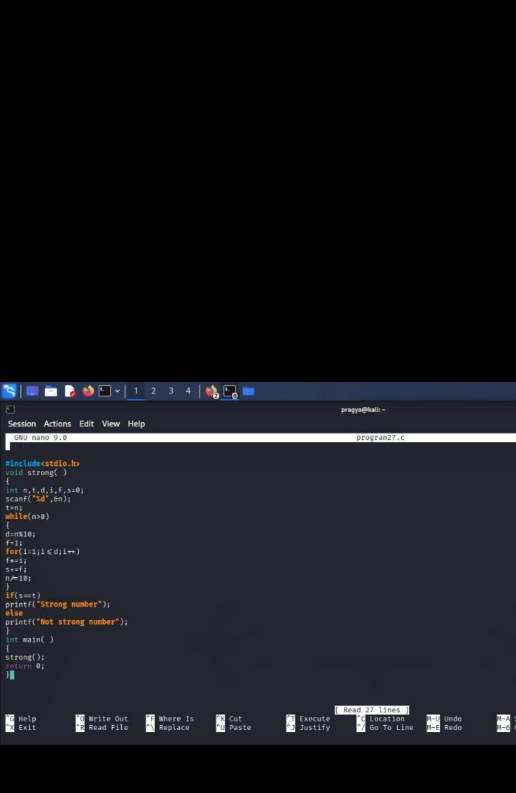

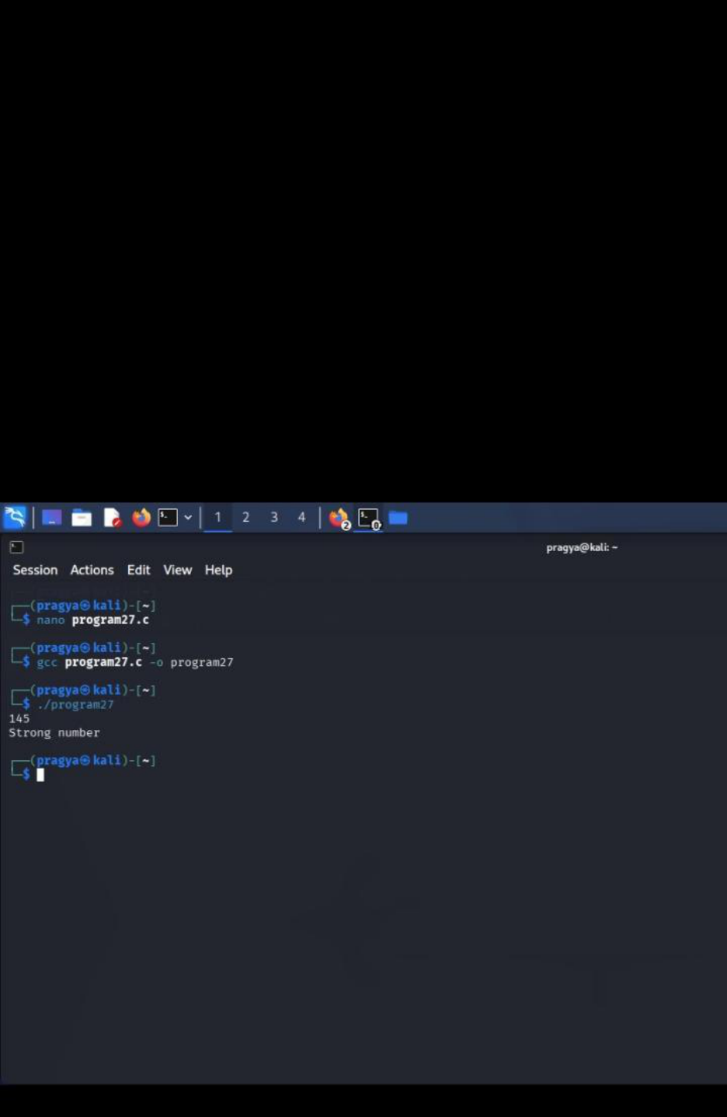

2. Armstrong Number
Algorithm:
1)Start.
2)Enter a number.
3)Separate its digits.
4)Find the sum of cubes of digits.
5)If sum = original number → Armstrong Number.
6)Otherwise → Not Armstrong Number.
7)Stop.
C code
void armstrong()
{
int n,t,d,s=0;
scanf("%d",&n);
t=n;
while(n>0)
{
d=n%10;
s=s+d*d*d;
n=n/10;
}
if(s==t)
printf("Armstrong Number");
else
printf("Not Armstrong Number");
}
Return 0;
}

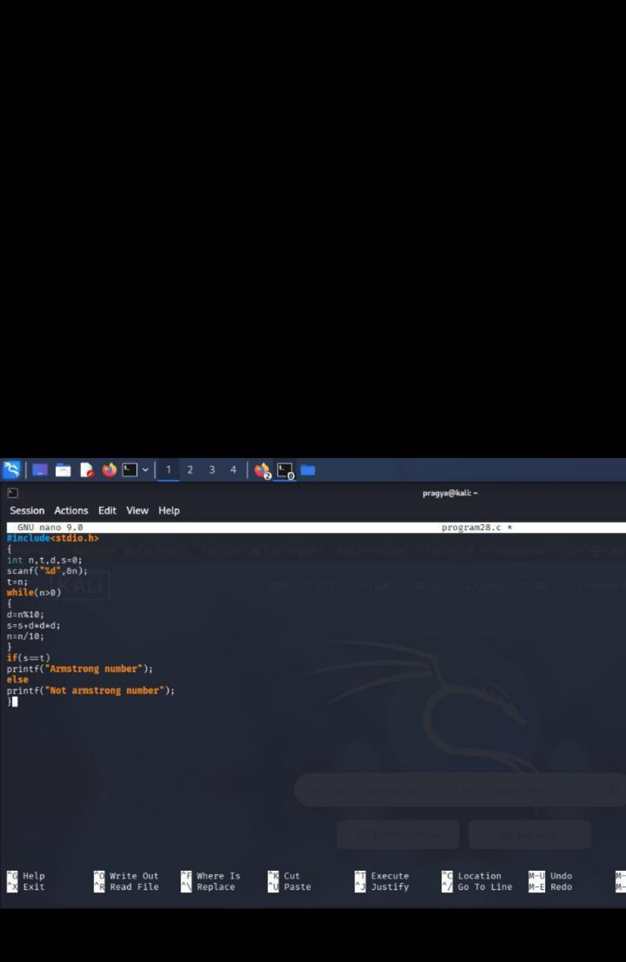

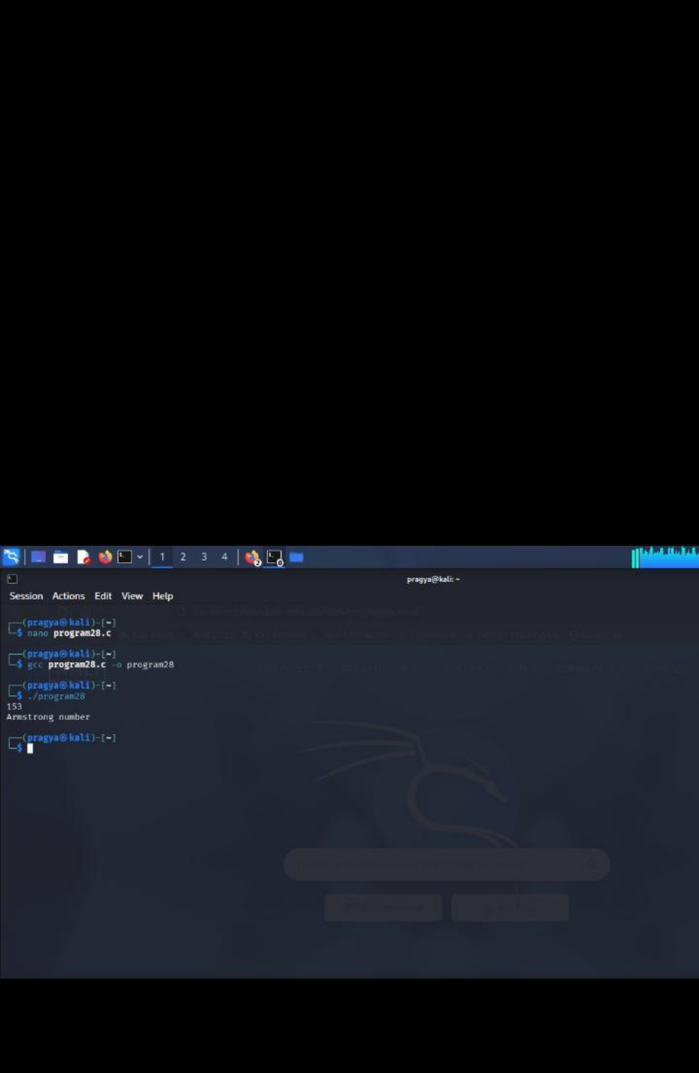

Result:
The program successfully checks whether the given number is an Armstrong number or not.
3. Harshad Number
C code
#include<stdio.h>
void harshad()
{
int n,t,d,s=0;
scanf("%d",&n);
t=n;
while(n>0)
{
d=n%10;
s=s+d;
n=n/10;
}
if(t%s==0)
printf("Harshad number");
else
printf("Not Harshad number");
}
int main()
{
harshad();
return 0;
}

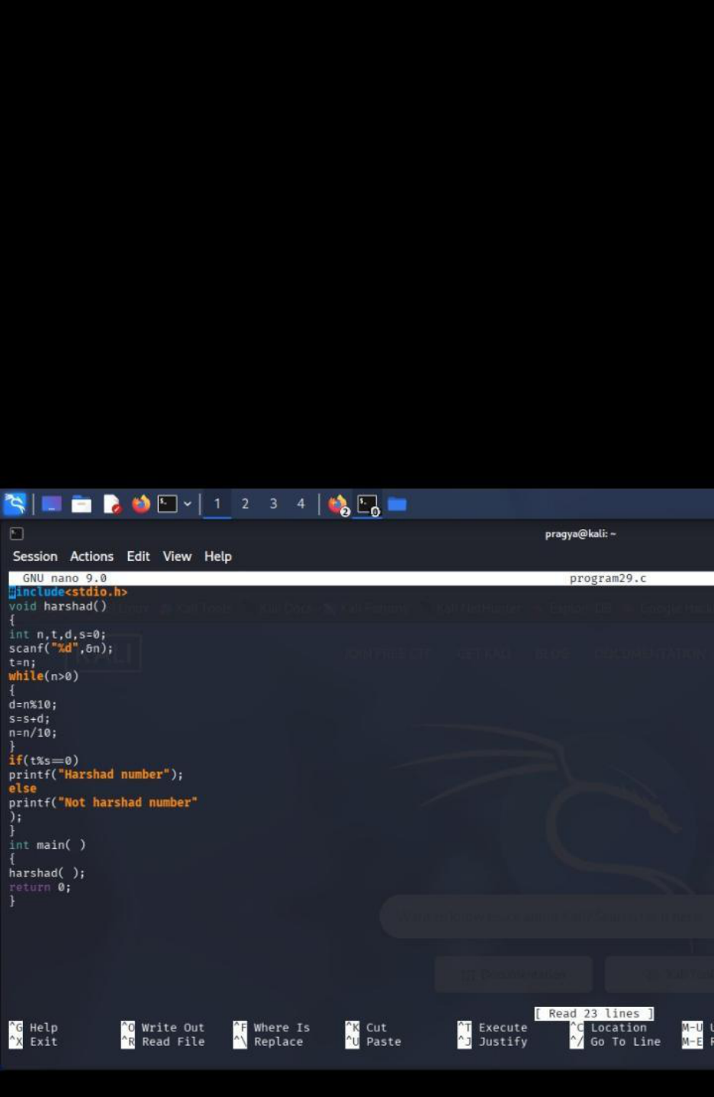

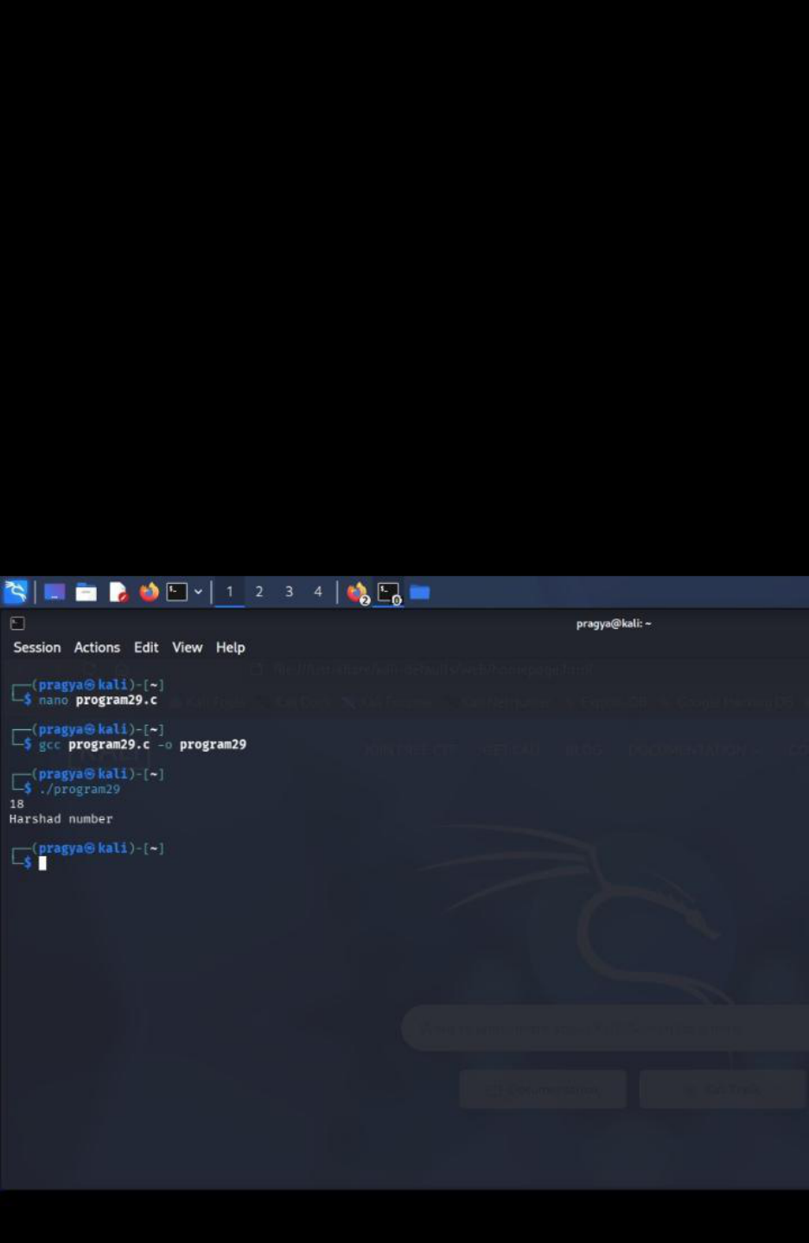

4. Duck Number
C code
#include<stdio.h>
void duck()
{
int n,d,f=0;
scanf("%d",&n);
while(n>0)
{
d=n%10;
if(d==0)
f=1;
n=n/10;
}
if(f==1)
printf("Duck number");
else
printf("Not Duck number");
}
int main()
{
duck();
return 0;
}

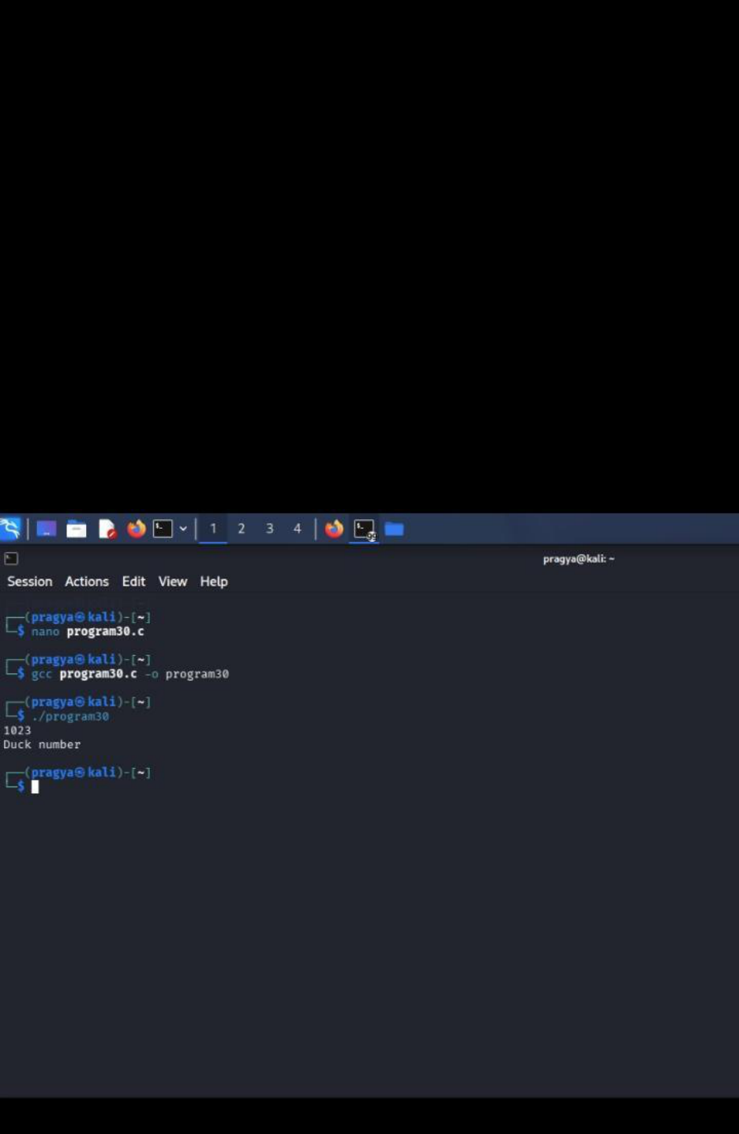

Result:
The menu-driven C program was successfully executed to check whether the given number is a
Strong, Armstrong, Harshad, or Duck number using separate user-defined functions.
Thank you
Pragya pandey
Sap id -590034352
Batch 15

